**MA35210:Topics In Biological Statistics**

**MANOVA Workbook**

Q2)a)

Check null hypothesis ?

F

b)

Check null hypothesis?

c) 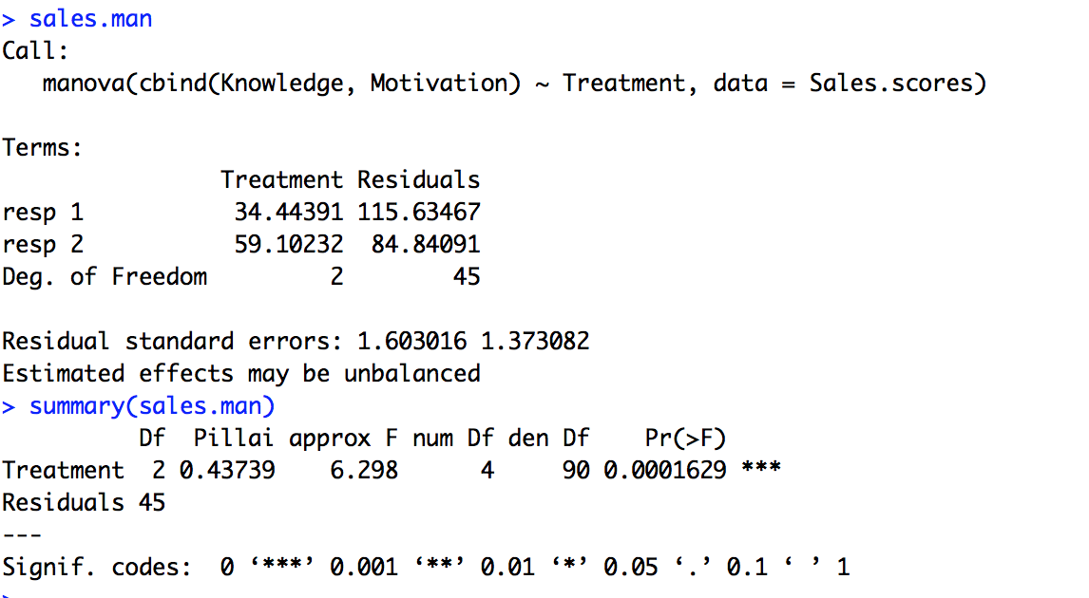

Test null hypothesis. Report findings and state conclusion

Q3)a)

Test weather each of the four measurments are different for irises of different species?

b)

What is the problem with carrying out four indepoedndent one-way ANOVAs in terns of the probability of a type 1 error? Explain how you could use a Bonferroni correction to account for multiple testing

Every time you conduct a t-test there is a chance that you will make a Type I error

The Bonferroni correction is an adjustment made to *P* values when several dependent or independent statistical tests are being performed simultaneously on a single data set.

The Bonferroni correction is used to reduce the chances of obtaining false-positive results (type I errors) when multiple pair wise tests are performed on a single set of data.

Interpret the output? Explain the difference between manova and repeated one-way anovas in the case of multivariate data ?

Q4) a)

What dose the MANOVA reveal in this case? Does it make any difference which of the four tests you use ?

Where does this analysis suggest the differences lie between the male and female centipedes?

Q5)a)

What are the two factors of interest here?

Report the p-values for the main effects and the interaction effect. What is your conclusion here? What are the fitted means for the different groups?

Report findings on summary.aov()

Q6)a)

What is the model for a one-way MANOVA in this case?

Quote the p-values

quote the p-values for all pairwise comparisons of treatment levels, including an explanation of the application of Bonferroni’s method to account for multiple testing.

d)

What does the output of summary.aov() applied to the MANOVA object tell you in this case

Comment on the pairwise plots, in light of the question of whether the measurements change over time.

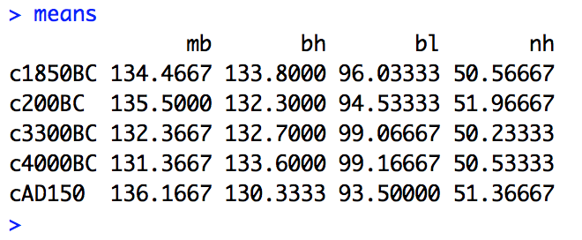

Explain the differences that you can see in the table (at this stage we do not know whether those differences are significant).

Include details of the pairwise multivariate tests comparing c4000BC with each progressively later time point (modify the code of question 7c).) You can address the multiple comparison issue by using a significance level of α=0.15 and carry out each test at the α/m level, where m is the number of tests carried out. 0.0375 is the pvalue smaller or larger what does this mean

Q8)a)

Because less than 0.05, 5% significance level herefore significant difference (star=good)

b)